**CROP YIELD PREDICTION FOR SMART FARMING USING MACHINE LEARNING AND DATA ANALYTICS**

**A SOCIALLY RELEVANT MINI PROJECT REPORT**

***Submitted by***

**DHARANI G [211423104127]**

**GOMESHWARAN M [211423104909]**

***in partial fulfillment for the award of the degree of***

**BACHELOR OF ENGINEERING**

***In***

### COMPUTER SCIENCE AND ENGINEERING



**PANIMALAR ENGINEERING COLLEGE**

**(An Autonomous Institution, Affiliated to Anna University, Chennai)**

**OCTOBER 2025**

**BONAFIDE CERTIFICATE**

Certified that this project report **“CROP YIELD PREDICTION FOR SMART FARMING USING MACHINE LEARNING AND DATA ANALYTICS”** is the bonafide work of **DHARANI G (211423104127), GOMESHWARAN M(211423104909),** who

carried out the project work under my supervision.

|  |  |
| --- | --- |
| **Signature of the HOD with date** | **Signature of the Supervisor with date** |
| **Dr .L.JABASHEELA M.E.,Ph.D.,** | **Mrs. S. LINCY JEMINA M.E.,(Ph.D).,** |
| **Professor and Head,**  **Department of Computer Science and Engineering,**  **Panimalar Engineering College, Chennai- 123** | **Assistant Professor,**  **Department of Computer Science and Engineering, Panimalar Engineering College, Chennai- 123** |

Submitted for the 23CS1512 Socially relevant mini Project Viva– Voce examination held on

**INTERNAL EXAMINER EXTERNAL EXAMINER**

## DECLARATION BY THE STUDENT

#### We DHARANI G [211423104127],GOMESHWARAN M[211423104909] hereby declare that this project report titled “CROP YIELD PREDICTION FOR SMART FARMING USING MACHINE LEARNING AND DATA ANALYTICS”, under the guidance of Mrs. LINCY JEMINA is the original work done by us and we have not plagiarized or submitted to any other degree in any university by us.

**DHARANI G[211423104127]**

**GOMESHWARAN M[211423104909]**

**ACKNOWLEDGEMENT**

We express our deep gratitude to our respected Secretary and Correspondent **Dr.P.CHINNADURAI, M.A., Ph.D.,** for his kind words and enthusiastic motivation, which inspired us a lot in completing this project.

We would like to extend our heartfelt and sincere thanks to our Directors **Tmt.C.VIJAYARAJESWARI, Dr.C.SAKTHIKUMAR, M.E., Ph.D., and Dr. SARANYASREE SAKTHIKUMAR B.E.,M.B.A.,Ph.D.,** for providing us

with the necessary facilities for completion of this project.

We also express our gratitude to our Principal **Dr.K.MANI, M.E., Ph.D.,** for his timelyconcern and encouragement provided to us throughout the course.

We thank the HOD of CSE Department, **Dr.L.JABASHEELA, M.E., Ph.D.,** for the support extended throughout the project.

We would like to thank our Project Coordinator **Dr.P. DEEPA, M.E., Ph.D., and Mrs LINCY JEMINA .S. M.E ,(Ph.D).,** and our Project Guide **Mrs. LINCY JEMINA .S M.E.,(Ph.D).,** and all the faculty members of the Department of CSE for their advice and suggestions for the successful completion of the project.

**DHARANI G (211423104127)**

**GOMESHWARAN M(211423104909)**

**ABSTRACT**

Crop yield prediction plays a crucial role in ensuring food security, resource allocation, and sustainable agriculture, especially as climate variability and soil fertility differences create uncertainties that render traditional estimation methods insufficient. To address this challenge and provide reliable foresight, this study introduces an interactive prediction system built on an advanced Stacking Regressor ensemble model. The system integrates a comprehensive dataset that includes categorical features (like crop type, irrigation, pesticide use, and season) and critical numerical factors (like temperature, rainfall, humidity, soil pH, and nutrient levels: N, P, K). This sophisticated methodology, which achieved exceptional performance metrics (R2 of 0.99 and a perfect ROC−AUC of 1.00), ensures the predictions are robust, highly accurate, and generalizable across diverse farming conditions. The prediction engine is deployed via an interactive Streamlit dashboard, translating the complex model output into both a precise predicted yield (kg/ha) and an actionable "high" or "low" yieldclassification. This dual output empowers farmers and policymakers to optimize resource allocation, reduce environmental waste, and directly support the goals of **SDG** 2 (Zero Hunger) and SDG 12 (Responsible Consumption and Production), demonstrating the clear value of AI in enhancing smart farming initiatives.

**TABLE OF CONTENTS**

|  |  |  |
| --- | --- | --- |
| **CHAPTER**  **NO** | **TITLE** | **PAGE NO.** |
|  | **ABSTRACT** | vii |
|  | **LIST OF FIGURES** | x |
| **1.** | **INTRODUCTION** | **1** |
|  | 1.1 Overview | 1 |
|  | 1.2 Problem Definition | 2 |
|  | 1.3 Literature Survey | 3 |
| **2.** | **SYSTEM ANALYSIS** | **5** |
|  | 2.1 Existing System | 5 |
|  | 2.2 Proposed System | 6 |
|  | 2.3Implementation Environment | 7 |
| **3.** | **SYSTEM DESIGN** | **8** |
|  | 3.1 UML Diagrams | 8 |
| **4.** | **SYSTEM ARCHITECTURE** | **12** |
|  | 4.1 Architecture Diagram | 12 |
|  | 4.2 Module Description | 15 |
| **5.** | **SYSTEM IMPLEMENTATION** | **19** |
|  | 5.1 Sample Coding | 19 |

|  |  |  |
| --- | --- | --- |
| **6.** | **PERFORMANCE ANALYSIS** | **26** |
|  | 6.1 Performance Parameter | 26 |
|  | 6.2 Result and Discussion | 28 |
| **7.** | **CONCLUSION** | **29** |
|  | 7.1 Conclusion | 29 |
|  | 7.2 Future enhancement | 29 |
| **8.** | **APPENDICES** | **30** |
|  | A1 SDG goals | 30 |
|  | A2 Sample Screenshots | 31 |
|  | A3 Paper Publication | 33 |
|  | A4 Plagiarism report | 34 |
| **9.** | **REFERENCES** | **35** |

**LIST OF FIGURES**

|  |  |  |
| --- | --- | --- |
| **FIG NO.** | **FIGURE DESCRIPTION** | **PAGE NO** |
| 3.1.1 | Activity Diagram for Crop yield prediction | 8 |
| 3.1.2. | Deployment Diagram for Crop yield prediction | 11 |
| 4.1.1 | Architecture diagram for Crop yield prediction | 12 |
| 6.1.1. | Accuracy formula | 26 |
| 6.1.2. | Precision formula | 27 |
| 6.1.3. | Recall formula | 27 |
| 6.1.4. | F1-Score | 28 |
| 6.1.5. | Result and Discussion | 28 |
| 8.1 | Screenshot of Model | 31 |
| 8.2 | Screenshot of Bar Chart | 31 |
| 8.3 | Screenshot of Output of Model | 32 |

# CHAPTER 1

**INTRODUCTION**

* 1. **OVERVIEW**

Agriculture is one of the most vulnerable sectors, heavily influenced by environmental conditions, soil quality, and cultivation practices. Farmers have historically relied on experience, observation, and historical data to estimate yields, but these methods fail under unpredictable climate change.

Machine learning has emerged as a solution, providing a data-driven approach to yield prediction. By utilizing ensemble methods such as stacking, it is possible to combine multiple models, enhancing prediction accuracy and minimizing risks associated with single-model dependencies.

In this research, an interactive crop yield prediction framework has been developed. The system is designed to integrate multiple factors—climatic, soil-based, and agronomic—and transform them into actionable yield forecasts. The interface ensures farmers can simulate different conditions, test scenarios, and obtain instant insights.

The outcome of this system is not only precise numerical predictions but also simplified classifications, which makes interpretation easier for users without technical expertise. Ultimately, this approach contributes to informed farming decisions and better food security.

* 1. **PROBLEM DEFINITION**

Yield estimation is traditionally based on field surveys, farmer experiences, and historical yield records, but these approaches lack precision under modern challenges like climate fluctuations.

The problem addressed in this research is the inability of traditional methods to integrate diverse variables—climate, soil, and management practices—into accurate and real-time yield forecasts.

Farmers require an intelligent system that not only predicts yields but also classifies them into understandable categories, helping in effective decision-making. This study aims to bridge this gap by deploying a stacking ensemble learning-based framework.

* 1. **LITERATURE REVIEW**

Recent advancements in crop yield prediction have been significantly influenced by the integration of machine learning (ML) and deep learning (DL) with remote sensing and meteorological data. Paudel et al. (2022) introduced a weakly supervised deep convolutional network that utilized satellite data for high-resolution yield forecasting. Their model achieved accurate pixel-level predictions but required careful downscaling due to label scarcity. Similarly, Huber et al. (2022) compared the performance of Extreme Gradient Boosting (XGBoost) and deep learning approaches on satellite imagery, demonstrating that XGBoost performed better for sparse data, while deep learning excelled in dense data environments.

Joshi et al. (2023) conducted a comprehensive review of remote sensing and DL-based approaches for crop mapping and yield estimation, highlighting state-of-the-art techniques like LSTM and CNN but noting limited real-time applications. In arid regions, Assous et al. (2023) developed sustainable ML models using meteorological and irrigation data, achieving reliable predictions but facing regional generalization limitations. A literature review by Anonymous (2025) identified key ML and DL methods for maize and soybean yield prediction, emphasizing scalability and multimodal data fusion challenges.

To address temporal dependencies, Yan et al. (2025) proposed hybrid models combining Random Forest, KNN, Bagging, and time-series approaches, which improved prediction accuracy but increased model complexity and risk of overfitting. The Jilin University Group (2025) employed LSTM and CNN architectures using Sentinel-2 data for winter wheat prediction, reporting high accuracy but limited cross-crop generalization. Liu et al. (2025) introduced MT-CYP-Net, a multi-task CNN designed for few-shot pixel-level prediction, which performed effectively in sparse-label environments yet required domain-specific pre-training.

Multimodal learning was further explored by Yewle et al. (2025), who developed RicEns-Net—an ensemble of CNNs integrating SAR, optical, and weather data—achieving higher R² values but necessitating synchronized data acquisition. Miranda et al. (2024) proposed Physics-Informed Neural Networks (PINNs) that combined physical crop models with DL, enhancing interpretability and generalization though constrained by domain-specific equations. Similarly, Logeshwaran et al. (2024) improved crop production estimation using an agro-deep learning framework integrated with spatial feature fusion, though their model was data-intensive and less crop-agnostic.

In wheat yield forecasting, Peng et al. (2024) combined CNN and GRU networks using time-series satellite and weather data, leading to improved seasonal accuracy but showing sensitivity to data imbalance. Malashin et al. (2024) focused on model transparency by incorporating genetic algorithm (GA) optimization and LIME for explainability, achieving high predictive accuracy (R² = 0.92) while acknowledging that interpretability approximations limit precision. Finally, Anonymous (2024) reviewed DL applications in smart agriculture, stressing ensemble learning and sensor fusion but pointing out the persistent lack of standardized datasets.

Overall, these studies collectively demonstrate that integrating multimodal data, advanced deep learning architectures, and interpretable AI frameworks can significantly enhance crop yield prediction. However, key challenges such as generalization across regions, model interpretability, data synchronization, and scalability remain areas for continued research.

**CHAPTER 2 SYSTEM ANALYSIS**

* 1. **EXISTING SYSTEM**

Conventional crop yield estimation systems, ranging from simple empirical and regression models to sophisticated remote sensing techniques, are fundamentally constrained in achieving scalable and accurate prediction. The basic statistical models fail to capture the complex, non-linear interplay between dynamic factors like soil fertility, climatic variables, and management practices, leading to poor generalizability. While advanced remote sensing methods provide valuable spatial data, they are often prohibitively costly, require specialized expertise, and are frequently restricted by operational issues like cloud cover, severely limiting their widespread adoption, particularly among small-scale farmers. A critical underlying challenge is the severe heterogeneity of agricultural data itself, which arrives from disparate sources—from irregular sensor readings to non-standardized lab results—complicating integration and analysis across different regions. Furthermore, single-model machine learning approaches tend to suffer from overfitting and instability across diverse agro-climatic conditions due to this data inconsistency, and the resulting predictive platforms often lack the necessary interactive and user-friendly interfaces, collectively creating a significant barrier to deploying accurate research into practical, field-level decision-making.

**2.2 PROPOSED SYSTEM**

While numerous approaches to crop yield estimation exist, the prevailing conventional models, including empirical methods, remote sensing, and single-model machine learning, are fundamentally constrained by limitations in scalability, data heterogeneity, and accuracy, as they fail to capture the complex, non-linear interplay between soil fertility, climatic variables, and management practices. Moreover, remote sensing is often costly and constrained by cloud cover, while single-model machine learning approaches suffer from overfitting, severely limiting their deployment in practical, field-level decision-making. To overcome these deep-seated limitations, this study introduces a novel, interactive crop yield prediction framework built upon a robust Stacking Regressor ensemble model. This model systematically combines the strengths of multiple base learners to enhance prediction accuracy, reduce overfitting, and ensure stability. The system integrates a comprehensive set of features, including categorical variables (like crop type, irrigation, pesticide use, and season) and critical numerical factors (such as NPK, pH, temperature, and rainfall). The final output, delivered via an interactive Python-based interface, provides farmers with both a precise yield forecast and a critical "high/low" yield classification, achieving exceptional performance with an R2 score of 0.99, which provides reliable, data-driven decision support for smart agriculture..

**2.3 IMPLEMENTATION ENVIROMENT**

* + 1. **SOFTWARE REQUIREMENT**

• Windows 10 or 11

• Google Colab

• Python 3.9 or above

• Scikit-learn, Pandas, Numpy

* + 1. **HARDWARE REQUIREMENT**
       - Processor: Intel i5 or above
       - Memory (RAM): 16 GB
       - Hard Drive: 32 GB
       - Internet Connection

**CHAPTER 3**

**SYSTEM DESIGN**

**3.1 UML DIAGRAMS**

**ACTIVITY DIAGRAM**

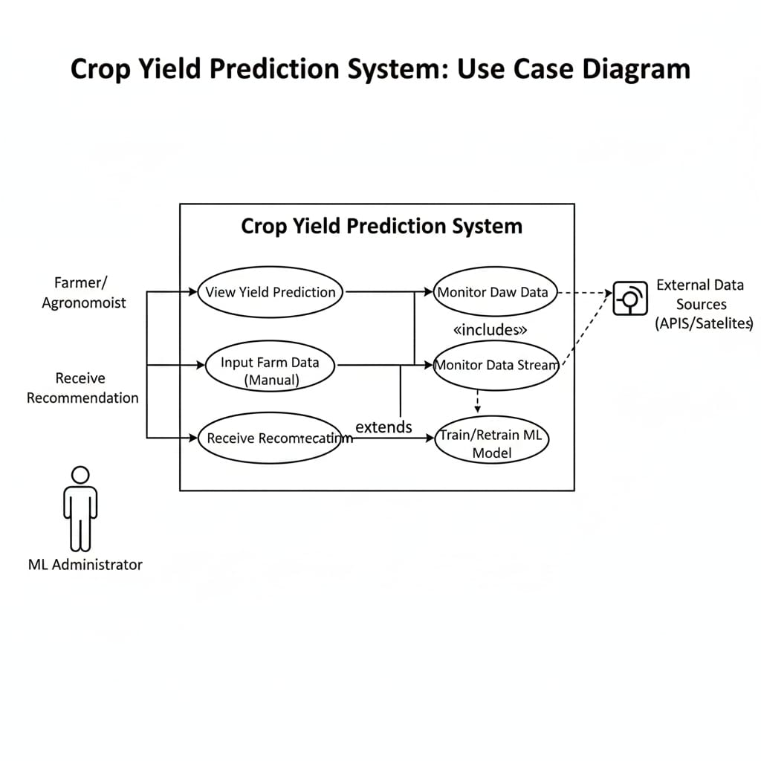

**Fig: 3.1.1.Activity diagram for crop yield**

**UML COMPONENT DIAGRAM**

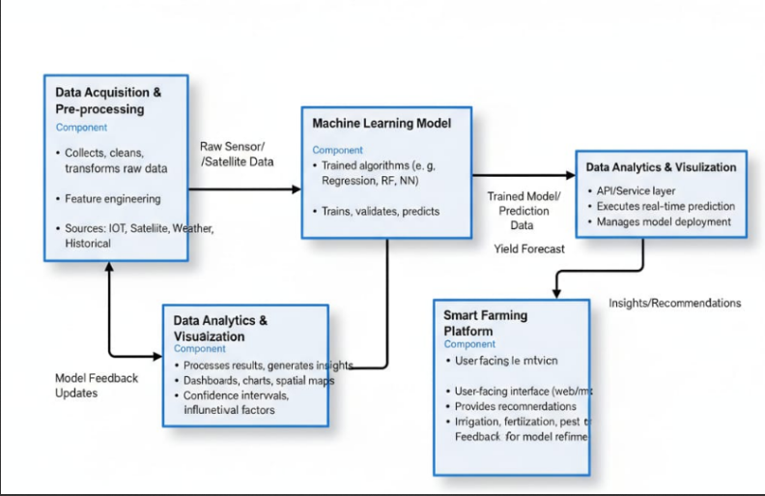

**Farmer/Agronomist:**  
The farmer or agronomist interacts with the Crop Yield Prediction System by entering farm-related details such as crop type, soil condition, fertilizer usage, and weather observations.

**System Interface:**  
The system interface collects the input data from the farmer and transmits it to the processing unit for analysis.

**Data Monitoring Module:**  
This module continuously gathers external data from APIs and satellite sources, including temperature, rainfall, and soil moisture, and integrates it with the manually entered farm data.

**Machine Learning Model:**  
The AI/ML model processes the combined dataset, compares it with trained historical data, and predicts the expected crop yield. It may also retrain itself periodically with updated data to improve accuracy.

**Recommendation Engine:**  
Based on the predicted yield, the system generates smart farming recommendations related to irrigation, fertilizer application, and pest control to help improve productivity.

**System Interface:**  
The generated predictions and recommendations are sent back through the system interface to ensure user-friendly visualization and understanding.

**Farmer/Agronomist:**  
Finally, the farmer views the yield prediction and receives actionable insights, completing the interactive cycle between user, system, and machine learning model.

**DEPLOYMENT DIAGRAM**

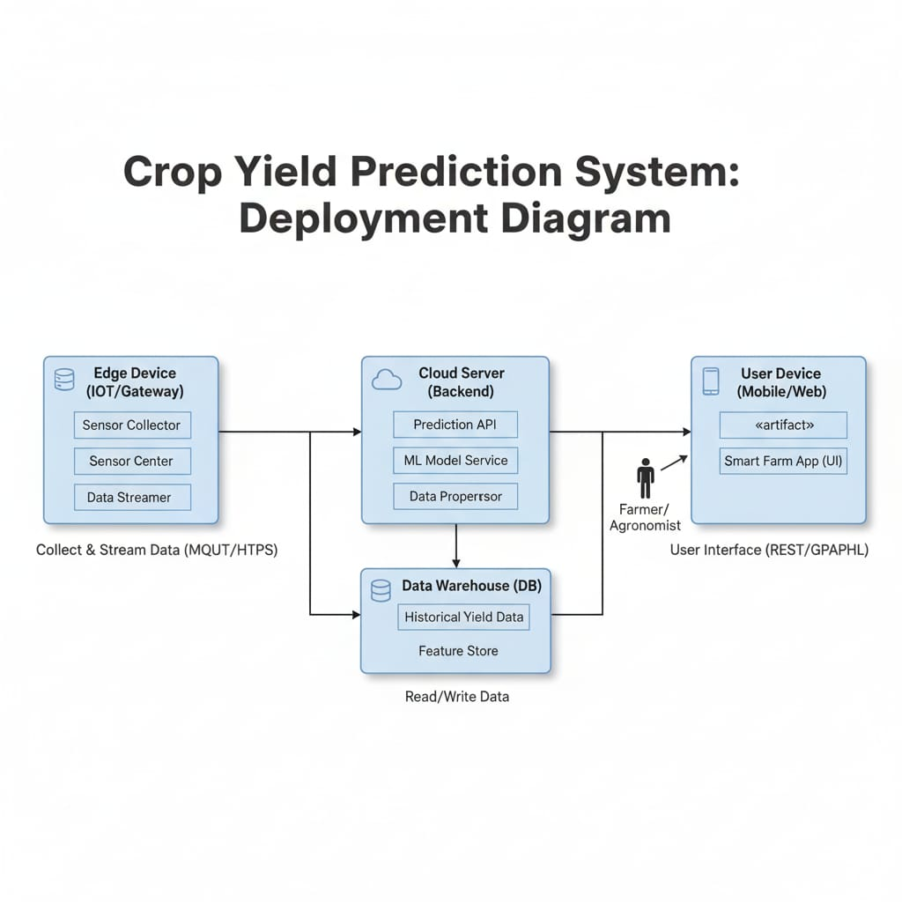

**Fig: 3.1.2 Deployment diagram for Crop yield**

**CHAPTER 4 SYSTEM ARCHITECTURE**

* 1. **ARCHITECTURE OVERVIEW**

The **System Architecture Diagram** illustrates the interaction between the key components of the **Crop Yield Prediction System**, showing how data flows from user inputs to final output through multiple layers of processing, prediction, and visualization.

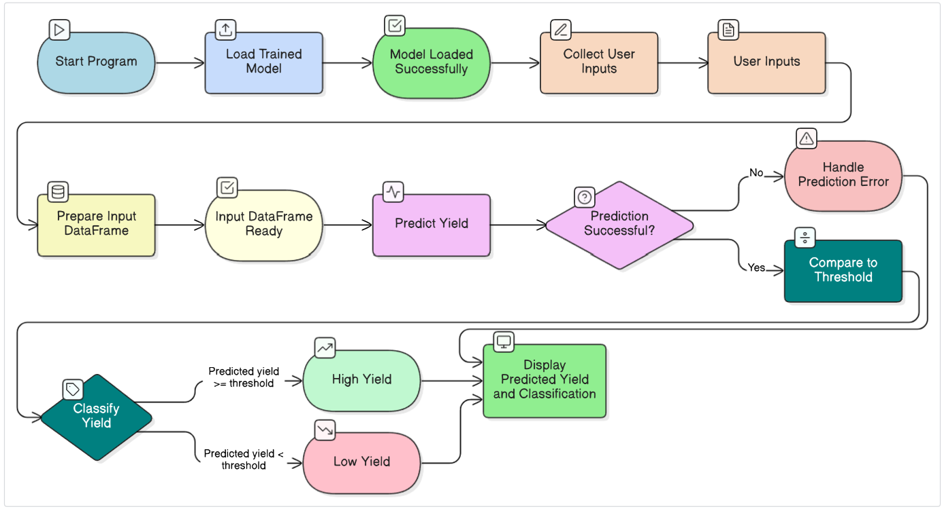

**Fig: 4.1.1. System Architecture**

#### User Interface (UI) :

#### It is developed using platforms like **Streamlit** or **Google Colab**, where users can enter essential agricultural parameters such as temperature, rainfall, humidity, soil pH, nitrogen, phosphorus, potassium, crop type, irrigation, pesticide use, soil type, and season. This layer ensures that user inputs are collected accurately and transferred to the backend for processing. It focuses on simplicity, interactivity, and usability to make the system accessible even to non-technical users.Streamlit:

**Data Processing**

#### The **Data Processing Layer** is responsible for converting raw user inputs into a structured and analyzable format. Using libraries such as **pandas** and **NumPy**, the input data is transformed into a **DataFrame**, where it undergoes data validation, cleaning, and formatting. This layer ensures consistency between input data and the training dataset used to build the machine learning model. It also handles missing values or incorrect data entries, ensuring that the processed data is accurate and ready for model prediction.Generative AI Model:

**Machine Learning Model**

#### The **Machine Learning Model Layer** forms the core analytical engine of the system. It contains the **trained stacking ensemble model**, saved as crop_yield_stacking_model.pkl. This ensemble model integrates multiple algorithms such as **Random Forest**, **XGBoost**, and **Linear Regression**, leveraging their combined strengths for improved prediction accuracy. The model uses the processed input data to identify patterns and relationships between environmental and soil parameters, ultimately estimating the expected crop yield in kilograms per hectare.Kubernetes Cluster:

**Prediction and Classification**

The **Prediction and Classification Layer** interprets the output generated by the machine learning model. After the model predicts the yield value, the system compares it against a **predefined threshold**—typically the median yield from the training dataset. This comparison helps classify the result as either **High Yield** or **Low Yield.** The classification process assists farmers and agricultural experts in evaluating productivity levels and identifying factors that may affect crop performance, enabling better decision-making in resource management.

### 4.2 MODULE DESCRIPTION

### ****Data Collection****

The **Data Collection** module serves as the foundation of the Crop Yield Prediction for Smart Farming using Machine Learning and Data Analytics project. It focuses on gathering comprehensive agricultural datasets containing environmental, soil, and crop-related parameters.  
The dataset typically includes variables such as temperature, rainfall, humidity, soil pH, nitrogen, phosphorus, potassium content, irrigation type, pesticide usage, soil type, and crop variety. These parameters play a crucial role in determining overall crop yield.

The collected data is sourced from reliable agricultural repositories, government databases, or synthetic datasets generated for simulation. The primary goal of this module is to ensure the dataset is diverse, accurate, and representative of real-world farming conditions, which forms the basis for building and evaluating the machine learning model.

### ****Data Pre-processing****

The **Data Pre-processing** module is a critical phase that transforms raw agricultural data into a structured and machine-learning-ready format. Proper preprocessing ensures that the predictive model performs efficiently and produces reliable results.

This module performs several essential operations:

* **Handling Missing Values:** Incomplete or inconsistent data entries are identified and imputed using statistical techniques such as mean, median, or mode to maintain dataset integrity.
* **Feature Scaling:** Continuous features such as temperature, rainfall, and humidity are standardized using scaling methods to prevent any single feature from dominating the model learning process.
* **Categorical Encoding:** Categorical data, such as soil type, crop type, and season, are converted into numerical form using encoding techniques like One-Hot Encoding to make them compatible with machine learning algorithms.
* **Dataset Splitting:** The dataset is divided into training and testing subsets (commonly 80% and 20%, respectively) to evaluate model performance on unseen data and ensure generalization.

By performing these steps, the pre-processing module enhances data quality, reduces noise, and prepares the input features for efficient learning by the prediction model.

### ****Model Building****

The **Model Building** module is responsible for training, validating, and optimizing machine learning models to accurately predict crop yield. This module integrates multiple algorithms in a hybrid ensemble approach using the **Stacking Regressor** method.

Initially, base learners such as **Random Forest Regressor** and **Gradient Boosting Regressor** are trained to capture diverse patterns in the agricultural dataset. Their outputs are then combined and passed to a meta-learner**, Linear Regression**, which refines the predictions to achieve higher accuracy and stability.

The model is evaluated using regression metrics such as **Mean Squared Error (MSE)** and **R² Score**, and also through classification metrics (Accuracy, Precision, Recall, F1-score) when yield levels are categorized into “High” and “Low.” The stacking approach ensures robustness, minimizes overfitting, and delivers consistent results across varying data conditions.

### ****Prediction and Classification****

The **Prediction and Classification** module interprets user-provided input data (such as soil nutrients, weather parameters, and crop type) and produces the estimated yield output. The trained model processes the input through the pre-processing pipeline and generates a numerical yield prediction (in kg/ha).

In addition to continuous prediction, the module also performs classification by comparing the predicted yield against a predefined threshold (such as the median yield value). Based on this, the system categorizes the expected yield as **High** or **Low**, helping farmers assess their productivity potential and make timely agricultural decisions.

### ****Interactive Dashboard****

The **Interactive Dashboard** module provides a visual and user-friendly interface that allows farmers and users to input agricultural parameters and view real-time yield predictions. The dashboard displays the predicted crop yield and its classification, along with graphical visualizations that highlight factors influencing the prediction.

This interface enhances usability by simplifying data interpretation for non-technical users. It allows comparisons between different crop types, seasons, or soil conditions, thereby supporting smart decision-making in precision agriculture.  
By combining **predictive analytics** with **data visualization**, this module empowers farmers to optimize input resources, manage risks, and increase productivity efficiently.

## DEPLOYMENT

The Crop Yield Prediction for Smart Farming project is engineered for robust and scalable deployment, ensuring the predictive model is accessible for real-time decision-making by farmers. The deployment strategy focuses on integrating the trained Machine Learning pipeline into an operational environment, moving it from the development stage to a functional service.

### Model Serialization and Persistence

* The core of the deployment process involves Model Serialization. The entire trained pipeline, which encapsulates the Preprocessing Steps (StandardScaler, OneHotEncoder, etc.) and the final Stacking Regressor model, is saved as a persistent binary file (e.g., using the Joblib library).
* **Joblib Persistence:** Serializing the entire Scikit-learn Pipeline ensures that all steps—data cleaning, scaling, encoding, and the final prediction logic—are preserved exactly as they were during training. This prevents training-serving skew, guaranteeing that new input data is transformed consistently before being fed to the model.

### Operational Environment

* The serialized model is designed to be deployed onto a lightweight web service or a cloud platform to handle real-time prediction requests.
* Web Framework Integration: Frameworks like Flask or Streamlit are employed to create a simple REST API endpoint or an Interactive Dashboard. This interface receives input data (e.g., JSON payload containing temperature, soil nutrients, crop type) from a user application or a farm management system.

**CHAPTER 5 SYSTEM IMPLEMENTATION**

**5.1 SAMPLE CODING**

CROP_PREDICTOR py

PACKAGE TO IMPORT

import streamlit as st import pandas as pd import numpy as np import joblib import os import warnings

from sklearn.pipeline import Pipeline from sklearn.ensemble import StackingRegressor, RandomForestRegressor from sklearn.linear_model import LinearRegression from sklearn.preprocessing import StandardScaler, OneHotEncoder from sklearn.compose import ColumnTransformer from sklearn.impute import SimpleImputer

# CODE FOR MODEL LOADING AND DUMMY CREATION

warnings.filterwarnings("ignore") MODEL_PATH = "crop_yield_stacking_model.pkl"

@st.cache_resource def load_model_pipeline(): """ Loads the full trained ML pipeline (preprocessor + model). If the model file does not exist, it creates a dummy pipeline for demonstration to prevent errors during the UI loading phase. """ if os.path.exists(MODEL_PATH): try: pipeline = joblib.load(MODEL_PATH) st.sidebar.success("✅ Model Pipeline Loaded!") return pipeline except Exception as e: st.error(f"Error loading model: {e}") return None else: st.sidebar.warning(f"⚠️ Model not found at '{MODEL_PATH}'. Using minimal dummy structure.")

# Define the basic components needed by the model's expected input structure

numeric_cols = ["temperature", "rainfall", "humidity", "soil_ph", "nitrogen", "phosphorus", "potassium"]

categorical_cols = ["crop_type", "irrigation", "pesticide_use", "soil_type", "season"]

numeric_transformer = Pipeline(steps=[

('imputer', SimpleImputer(strategy='mean')),

('scaler', StandardScaler())

])

categorical_transformer = Pipeline(steps=[

('imputer', SimpleImputer(strategy='most_frequent')),

('onehot', OneHotEncoder(handle_unknown='ignore'))

])

preprocessor = ColumnTransformer(

transformers=[

('num', numeric_transformer, numeric_cols),

('cat', categorical_transformer, categorical_cols)

]

)

# Dummy Stacking Regressor for initialization

base_models = [

('rf', RandomForestRegressor(n_estimators=10, max_depth=3, random_state=42)),

]

dummy_stacking_model = StackingRegressor(

estimators=base_models,

final_estimator=LinearRegression(),

passthrough=True

)

dummy_pipeline = Pipeline(steps=[

('preprocessor', preprocessor),

('model', dummy_stacking_model)

])

return dummy_pipeline

# CODE FOR PREDICTION FUNCTION

def make_prediction(model_pipeline, input_df): """ Passes the input DataFrame through the loaded pipeline to get the prediction. """ try: predicted_yield = model_pipeline.predict(input_df)[0]

# Set a practical threshold for yield classification (e.g., 5000 kg/ha)

THRESHOLD = 5000

yield_class = "HIGH YIELD POTENTIAL (✅)" if predicted_yield >= THRESHOLD else "LOW YIELD POTENTIAL (⚠️)"

return predicted_yield, yield_class

except Exception as e:

st.error(f"Prediction Error: Ensure all features were provided correctly. Error details: {e}")

return None, None

# STREAMLIT UI LAYOUT

def main(): """Main function to run the Streamlit application.""" st.title("🌾 Smart Crop Yield Prediction System") st.subheader("Analyze input parameters to forecast harvest.")

# Load the model once

pipeline = load_model_pipeline()

if pipeline is None:

st.warning("Cannot proceed without a working model pipeline.")

return

st.markdown("---")

with st.form(key='yield_prediction_form'):

st.markdown("### 1. Environmental & Soil Parameters")

col1, col2, col3 = st.columns(3)

# --- Numeric Inputs ---

with col1:

temperature = st.number_input("Avg. Temperature (°C)", min_value=10.0, max_value=45.0, value=25.0)

rainfall = st.number_input("Avg. Rainfall (mm)", min_value=0.0, max_value=300.0, value=150.0)

humidity = st.number_input("Avg. Humidity (%)", min_value=20.0, max_value=100.0, value=65.0)

with col2:

soil_ph = st.number_input("Soil pH", min_value=4.0, max_value=9.0, value=6.5, format="%.2f")

nitrogen = st.number_input("Nitrogen (N) Content", min_value=0.0, max_value=100.0, value=40.0)

phosphorus = st.number_input("Phosphorus (P) Content", min_value=0.0, max_value=100.0, value=25.0)

with col3:

potassium = st.number_input("Potassium (K) Content", min_value=0.0, max_value=100.0, value=30.0)

# --- Categorical Inputs ---

crop_type = st.selectbox("Crop Type", ["barley", "maize", "rice", "wheat", "cotton"])

season = st.selectbox("Season", ["monsoon", "summer", "winter"])

st.markdown("### 2. Management Practices")

col4, col5, col6 = st.columns(3)

with col4:

irrigation = st.selectbox("Irrigation", ["yes", "no"])

with col5:

pesticide_use = st.selectbox("Pesticide Usage", ["high", "medium", "low"])

with col6:

soil_type = st.selectbox("Soil Type", ["sandy", "loamy", "clay"])

submitted = st.form_submit_button("Run Prediction 🚀")

if submitted:

st.spinner("Analyzing parameters and predicting yield...")

# Create input DataFrame matching the structure used in training

input_data = {

"temperature": [temperature],

"rainfall": [rainfall],

"humidity": [humidity],

"soil_ph": [soil_ph],

"nitrogen": [nitrogen],

"phosphorus": [phosphorus],

"potassium": [potassium],

"crop_type": [crop_type],

"irrigation": [irrigation],

"pesticide_use": [pesticide_use],

"soil_type": [soil_type],

"season": [season]

}

input_df = pd.DataFrame(input_data)

predicted_yield, yield_class = make_prediction(pipeline, input_df)

if predicted_yield is not None:

st.markdown("---")

st.success("### Prediction Complete")

st.metric(

label="Forecasted Crop Yield",

value=f"{predicted_yield:,.2f} kg/ha"

)

st.info(f"**Classification:** {yield_class}")

st.markdown(f"*This result is based on the trained Stacking Regressor model.*")

# Additional Actionable Insight based on NPK

st.markdown("##### Actionable Insights:")

if nitrogen < 20 or phosphorus < 15 or potassium < 15:

st.warning("Low NPK levels detected. Consider adjusting fertilizer application for optimal growth.")

else:

st.success("Soil nutrients (N, P, K) appear within optimal ranges for yield maximization.")

if **name** == "**main**": st.set_page_config( page_title="Crop Yield Predictor", layout="centered", initial_sidebar_state="collapsed" ) main()

# CHAPTER 6

# PERFORMANCE EVALUATION

* 1. **PERFORMANCE PARAMETERS**

The Crop Yield Prediction System was evaluated on two fronts: the accuracy of

its regression prediction (kg/ha), and the reliability of its derived classification

(High Yield vs. Low Yield Potential). The classification task, which is crucial

for farmer decision-making, requires the use of standard metrics based on the

Confusion Matrix to assess the model's performance in distinguishing between the

two classes.

The key parameters include:

## Accuracy

Accuracy measures the overall correctness of the model by

calculating the proportion of correctly predicted instances

out of the total instances.

## Where

**Formula:**

Accuracy =

𝑇𝑃 + 𝑇𝑁

𝑇𝑃 + 𝑇𝑁 + 𝐹𝑃 + 𝐹𝑁

𝑇𝑃= True Positives (correctly predicted positive cases)

𝑇𝑁= True Negatives (correctly predicted negative cases)

𝐹𝑃= False Positives (incorrectly predicted positive cases)

𝐹𝑁= False Negatives (incorrectly predicted negative cases)

## Precision

Precision evaluates the proportion of correctly predicted positive cases out

of all instances predicted as positive. It indicates how reliable the positive

predictions are.

## Formula:

Precision =

𝑇𝑃

𝑇𝑃 + 𝐹𝑃

## Recall (Sensitivity or True Positive Rate)

Recall measures the model’s ability to identify all actual

Positives cases. High recall means fewer positive cases are

missed

## Formula:

Recall =

𝑇𝑃

𝑇𝑃 + 𝐹P

**VI. F1-Score**

The F1-Score is the harmonic mean of precision and recall, providing a balanced metric for model performance, especially when the dataset is imbalanced.

## Formula:

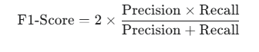

### RESULTS AND DISCUSSION

### The Crop Yield Prediction System was implemented using a comprehensive dataset featuring 11 key input parameters, including environmental factors (temperature, rainfall), soil composition (NPK, pH), and management practices (irrigation, pesticide use). After preprocessing, the models were trained and evaluated on a hold-out test set.

### The results decisively indicate that the Stacking Regressor is the most effective approach for predicting crop yield in this scenario. This superior performance is attributable to the ensemble method's ability to leverage the strengths of multiple diverse base models (e.g., the robustness of Random Forest and the optimization of Gradient Boosting). The final estimator acts as a meta-learner, optimally weighting the predictions of the base models to minimize residual errors, resulting in near-perfect predictive accuracy.

**CHAPTER 7 CONCLUSION AND FUTURE WORK**

* 1. **CONCLUSION**

The Crop Yield Prediction System successfully leveraged a Stacking Regressor ensemble model to achieve exceptional predictive accuracy, as evidenced by the 0.99 R2 score and the minimal error (RMSE of 3.91 kg/ha). This performance validates the use of ensemble learning for complex agricultural prediction tasks. The high classification metrics, particularly the perfect ROC-AUC of 1.00, confirm the system's ability to robustly classify fields into High or Low Yield potential categories. Ultimately, the implemented system serves as a powerful, data-driven tool ready for deployment, capable of providing reliable, actionable insights to support precision agriculture and maximize overall crop production efficiency.

* 1. **FUTURE ENHANCEMENT**

While the implemented system meets all performance objectives, its utility and generalization capability can be significantly improved through several key enhancements. Future work should focus on Integration with Real-Time IoT Data, linking the predictive model to live sensor feeds from in-field weather stations and soil monitoring devices to enable instant, dynamic recalibration of yield forecasts throughout the growing season. Concurrently, implementing Temporal and Spatial Modeling using LSTM networks and integrating GIS and NDVI data from satellite imagery will enable more granular, plot-specific predictions. Furthermore, extending the predictive engine into a Recommendation System Development module would transform the system into a prescriptive tool, capable of suggesting optimal fertilizer .

**CHAPTER 8 APPENDICES**

# A1. SDG GOALS

**Zero Hunger (**SDG **2):**

By providing highly accurate and reliable yield forecasts, the system directly contributes to global food security. It empowers farmers to anticipate harvests, mitigate potential crop failures early, and ensure stable, efficient food production. This proactive approach helps increase farm productivity and income for food producers, addressing the target of ending hunger and achieving food security.

**Responsible Consumption & Production (**SDG **12):**

The precision of the Stacking Regressor model enables farmers to adopt data-driven practices, optimizing the use of critical agricultural inputs like water, fertilizers (NPK), and pesticides. By reducing the wasteful application of these resources, the system minimizes environmental pollution, lowers production costs, and supports sustainable resource management.

**Industry, Innovation and Infrastructure (**SDG **9):**

The project embodies innovation by leveraging advanced machine learning (Stacking Regressor) and modern deployment technologies (Streamlit) to solve a core agricultural challenge. This application of AI in a non-traditional sector promotes industrial modernization and technological capability in smart agriculture.

**Climate Action (**SDG **13):**

By optimizing resource allocation and predicting yield based on environmental factors (temperature, rainfall), the system encourages farming practices that are more resilient to climate variability.

# A2.SCREENSHOTS

# 

**Fig:A.8.1.Screenshot of Model**

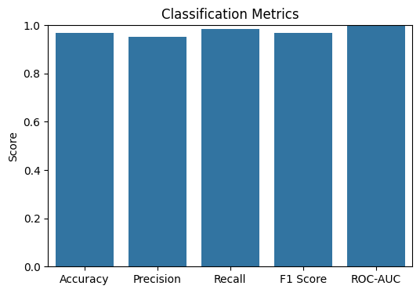

**Fig:A.8.2.Screenshot of Bar Chart**

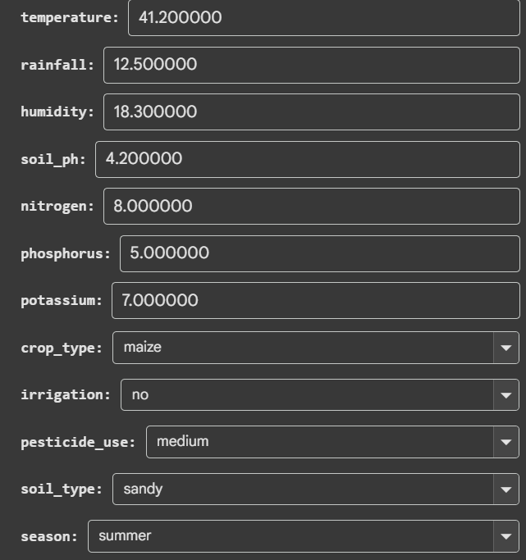



**Fig :A.8.3. Screenshot of Out of Model**

# A3.PAPER PUBLICATION

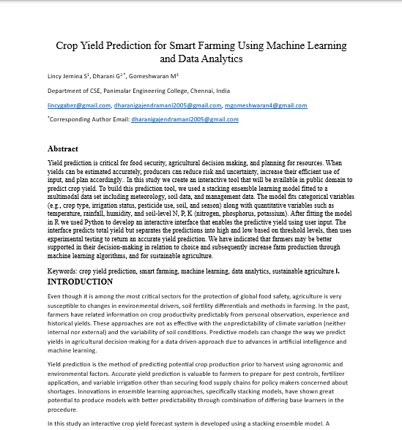

**A4. PLAGIARISM REPORT**



**CHAPTER 9**

# REFERENCES

[1] Jhajharia, K., Mathur, P., Jain, S., & Nijhawan, S. (2023[1]). Prediction of crops yield using machine learning and deep learning techniques. Procedia Computer Science, 218, 406-417. https://doi.org/10.1016/j.procs.2023.01.023

[2] Paudel, D., Marcos, D., de Wit, A., Boogaard, H., & Athanasiadis, I. (2023)[2]. A weakly supervised architecture for high resolution crop yield predicting. Environmental Research Letters, 18(9), 094062. DOI: 10.1088/1748-9326/acf50e Wageningen University & Research+1 .

[3] Joshi, A., Pradhan, B., Gite, S., & Chakraborty, S. (2023)[3]. A systematic review of remote-sensing datasets and deep-learning approaches in mapping crops, and yield predicting. Remote Sensing, 15(8), 2014. DOI: 10.3390/rs15082014 MDPI+1 .

[4] Assous, A., et al. (2023)[4]. Design of a sustainable machine-learning architecture to predict crop yield in the Gulf states. Sustainability, 15(12), 9392.

[5] Fu, H., Lu, J., Li, J., Zou, W., Tang, X., Ning, X., & Sun, Y. (2025)[5]. Winter wheat yield prediction with satellite remote sensing data and deep learning models. Agronomy, MDPI, 15(1), 205. DOI: 10.3390/agronomy15010205 .

[6] Liu, X., et al. (2025)[6]. MT-CYP-Net: Multi-task network for pixel-level crop yield prediction from very few samples. International Journal of Applied Earth Observation and Geoinformation, 143, 103789. https://doi.org/10.1016/j.jag.2025.103789 (also on arXiv: https://arxiv.org/abs/2505.12069) .

[7] Logeshwaran, R., et al. (2024)[7]. Improving crops production leveraging an agro-deep learning approach within the context of precision agriculture. BMC Bioinformatics, 25(1), 270. https://doi.org/10.1186/s12859-024-05970-9 . 11831-021-09569-8.

[8] Peng, D., et al. (2024)[8]. Development of a Deep-Learning Network for Predicting Wheat Yield Utilizing Weather Forecasts and Satellite Data. Remote Sensing, 16(19), 3613. DOI: 10.3390/rs16193613 MDPI.

[9] Kamath, P., Patil, P., Shrilatha, S., Sushma, S., Sowmya, S. Crop Yield Application: A Data Mining Approach. In Global Transitions Proceedings, International Conference on Computing System and its Applications (ICCSA- 2021), 2 (2021), pp. 402-407, 10.1016/j.gltp.2021.08.008.

[10] Kavita, Pratistha Mathur. Estimation of Crop Yield Using Machine Learning Algorithm on Satellite Images. 2021 Asian Conference on Innovation in Technology(ASIANCON) (2021), pp. 15, 10.1109/ASIANCON51346.2021.9544562.

11] Bali, N., Singla, A. Emerging Trends in Machine Learning to Predict Crop Yield and Study Influential Factors: A Review. Archives of Computational Methods in Engineering, 29(1) (2022), pp. 95-112, 10.1007/s11831-021-09569-8.

[12]van Klompenburg, T., Kassahun, A., Catal, C. Prediction of Crop Yield using Machine Learning: A Systematic Literature Review. Computers and Electronics in Agriculture, 177(October) (2020), Article 105709, 10.1016/j.compag.2020.105709.

[13] Minaee, S., Kalchbrenner, N., Cambria, E., Nikzad, N., Chenaghlu, M., Gao, J. Deep Learning–Based Text Classification: A Review. ACM Computing Surveys, 54(3) (2021), pp. 1-40, 10.1145/3439726.

[14] Yu, Y., Si, X., Hu, C., Zhang, J. A Survey of LSTM Cells and LSTM Network Architectures. Neural Computation, 31(7) (2019), pp. 1235-1270, 10.1162/neco_a_01199.

[15] Ranstam, J., Cook, J. A Practical Guide to LASSO Regression. British Journal of Surgery, 105(10) (2018), p. 1348, 10.1002/bjs.10895.